Session 2026-2027

Vision:Dream of where you want. | Mission: Means to achieve Vision

Program Educational Objectives of the program (PEO): (broad statements that describe the professional and career accomplishments)
PEO1 | Preparation | P: Preparation | Pep-CL abbreviation  pronounce as Pep-si-lL easy to recall
PEO2 | Core Competence | E: Environment (Learning Environment) | Pep-CL abbreviation  pronounce as Pep-si-lL easy to recall
PEO3 | Breadth | P: Professionalism | Pep-CL abbreviation  pronounce as Pep-si-lL easy to recall
PEO4 | Professionalism | C: Core Competence | Pep-CL abbreviation  pronounce as Pep-si-lL easy to recall
PEO5 | Learning Environment | L: Breadth (Learning in diverse areas) | Pep-CL abbreviation  pronounce as Pep-si-lL easy to recall

Program Outcomes (PO): (statements that describe what a student should be able to do and know by the end of a program)
Keywords of POs:
Engineering knowledge,Problem analysis, Design/development of solutions,Conduct Investigations of Complex Problems, Engineering Tool Usage, The Engineer and The World,Ethics, Individual and Collaborative Team work,Communication, Project Management and Finance, Life-Long Learning

PSO Keywords: Cutting edge technologies, Research

“I am an engineer, and I know how to apply engineering knowledge to investigate, analyse and design solutions to complex problems using tools for entire world following all ethics in a collaborative way with proper management skills throughout my life.” to contribute to the development of cutting-edge technologies and Research.

Integrity: I will adhere to the Laboratory Code of Conduct and ethics in its entirety.

Name and Signature of Student and Date
(Signature and Date in Handwritten)

Session | 2026-27 (ODD) |  | Course Name | Web Technology Lab
Semester | 3 |  | Course Code | 23CT1301
Roll No | 54 |  | Name of Student | Limay Tidke
Practical Number |  | 4 - A
Course Outcome |  | - Understand various internet technologies.  - Design the web pages using HTML and CSS.  - Implement the XML technology to store the data.  - Develop the interactive web pages using JavaScript.
Aim |  | Introduction to JavaScript
Problem Definition |  | Build a registration form (name, email, password, phone  number) and write JavaScript to validate all fields on submit, displaying inline error  messages
Theory  (100 words) |  | JavaScript is a programming language used to create dynamic content for websites. It is a lightweight, cross-platform, and single-threaded programming language. It's an interpreted language that executes code line by line, providing more flexibility.  - Client Side: On the client side, JavaScript works along with HTML and CSS. HTML adds structure to a web page, CSS styles it, and JavaScript brings it to life by allowing users to interact with elements on the page, such as actions on clicking buttons, filling out forms, and showing animations. JavaScript on the client side is directly executed in the user's browser.  - Server Side: On the Server side (on Web Servers), JavaScript is used to access databases, file handling, and security features to send responses, to browsers.
Procedure and Execution  (100 Words) |  | Step for Implementation:  Open a text editor (such as VS Code, Notepad, or Sublime Text).  - Create a new file named practical4a.html.  - Set up the standard HTML structure (<!DOCTYPE html>, <html>, <head>, <body>).  - Add an interactive element, such as an input field and a <button>, to trigger JavaScript execution.  - Define a JavaScript block inside <script> tags to read user input, run a basic greeting function, and dynamically update a heading or paragraph element on the page using the DOM.  - Save the file and open practical4a.html in a web browser.  - Click the button to observe dynamic content changes and inspect the browser console (F12) for output.
Code:

function card(event){
if (event) event.preventDefault();

let name = document.getElementById("name").value.trim();
let age = document.getElementById("age").value;
let email = document.getElementById("email").value;
let pass = document.getElementById("pass").value;
let phone = document.getElementById("phone").value;

let person = {
name : name,
age : age,
email : email,
pass : pass,
phone : phone,

};

if (check_valid(person)){
alert("Successfully submitted");
return true;
}
}

function check_valid(person){

//name validation
if (person.name == ""){
alert("Please enter valid name");
return false;
}

//age validation
if (person.age < 16 || person.age > 60){
alert("Invalid age must be between 16 and 60");
return false;
}

//email validation
let emailFormat = /@/;
if (!emailFormat.test(person.email)){
alert("Invalid email format");
return false;
}

if (person.pass.length < 6){
alert("Password must be 6 length");
return false;
}

//phone validation
let phoneformat = /^[0-9]{10}$/;
if (!phoneformat.test(person.phone)){
alert("invalid phone number");
return false;
}

return true;

}
Output:
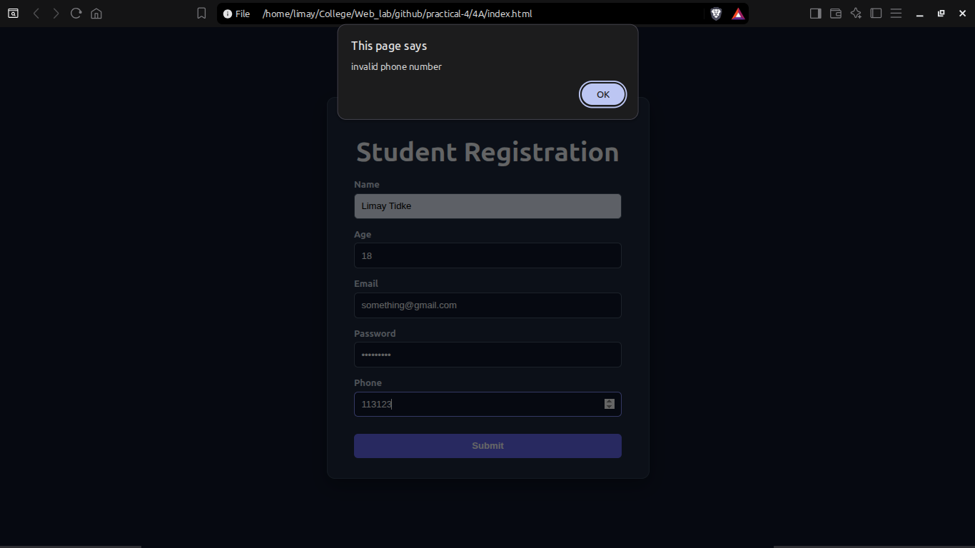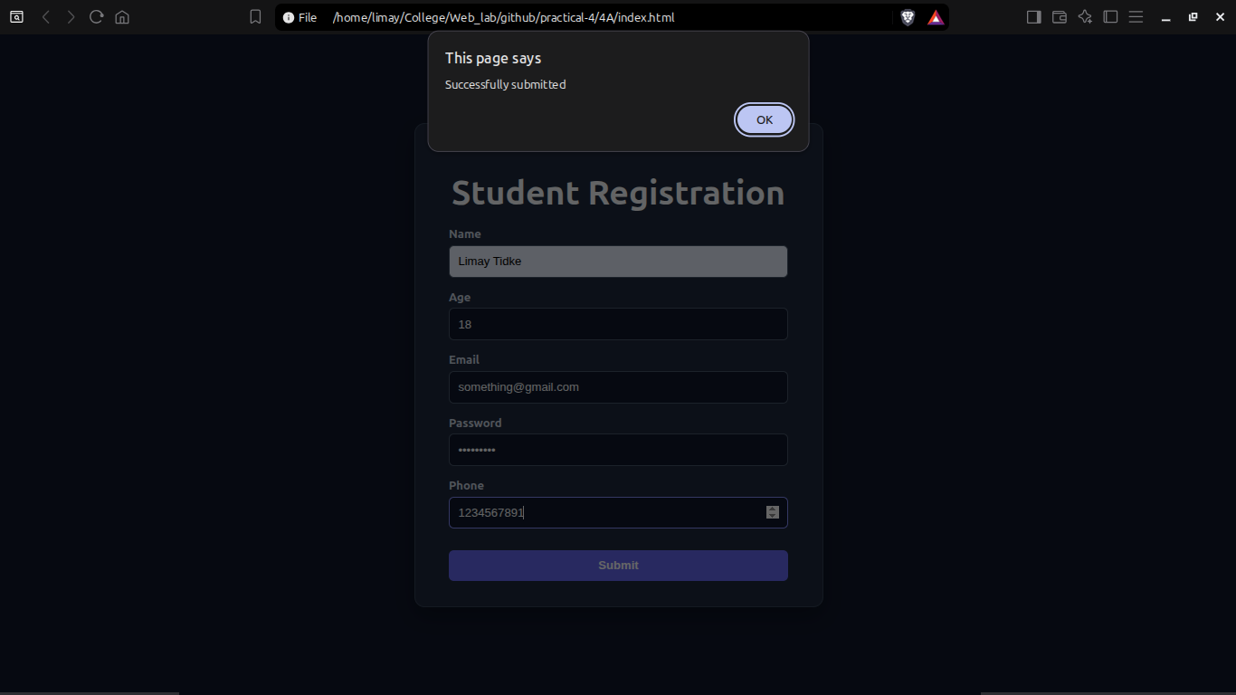
Output Analysis |  | Initial State: The browser displays multiple input boxes for different information.  - On Button Click (Valid Input): It takes the input entered in the fields and validates them. If all input are valid it displays a “Successfully submitted” message as shown in picture 2.  - On Button Click (Empty Input or Invalid input): If the field is left empty or the input provided is not in a valid format it displays an error as shown in picture 1.
Link of student Github profile where lab assignment has been uploaded |  | https://github.com/limaytidke
Conclusion |  | Successfully studied the fundamentals of JavaScript and demonstrated dynamic client-side scripting, event handling, and DOM element manipulation in a web environment.
Plag Report (Similarity index < 12%) |  | 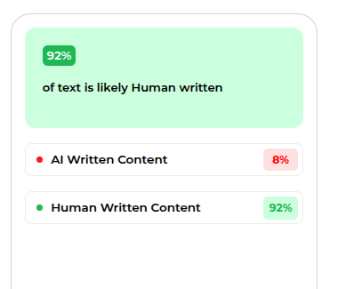
Date |  | 11/08/2026

